HopeLine Application Development

**This document is prepared by Edmel Ricahuerta**

**The purpose of this document is to help the development team on starting and developing the application** **for the semester.**

**Audience: Development Team (Group7)**

Follow these steps to build the application with ease:

# **PREPARE YOUR WORKINGF ENVIRONMENT**

###### **DOTNET**

Make sure to install NET Core 2.1 SDK on your machine before doing anything else. To check, run the following code:



If it does not exist or it is not recognized, download and install from here:

<https://www.microsoft.com/net/download/dotnet-core/2.1>

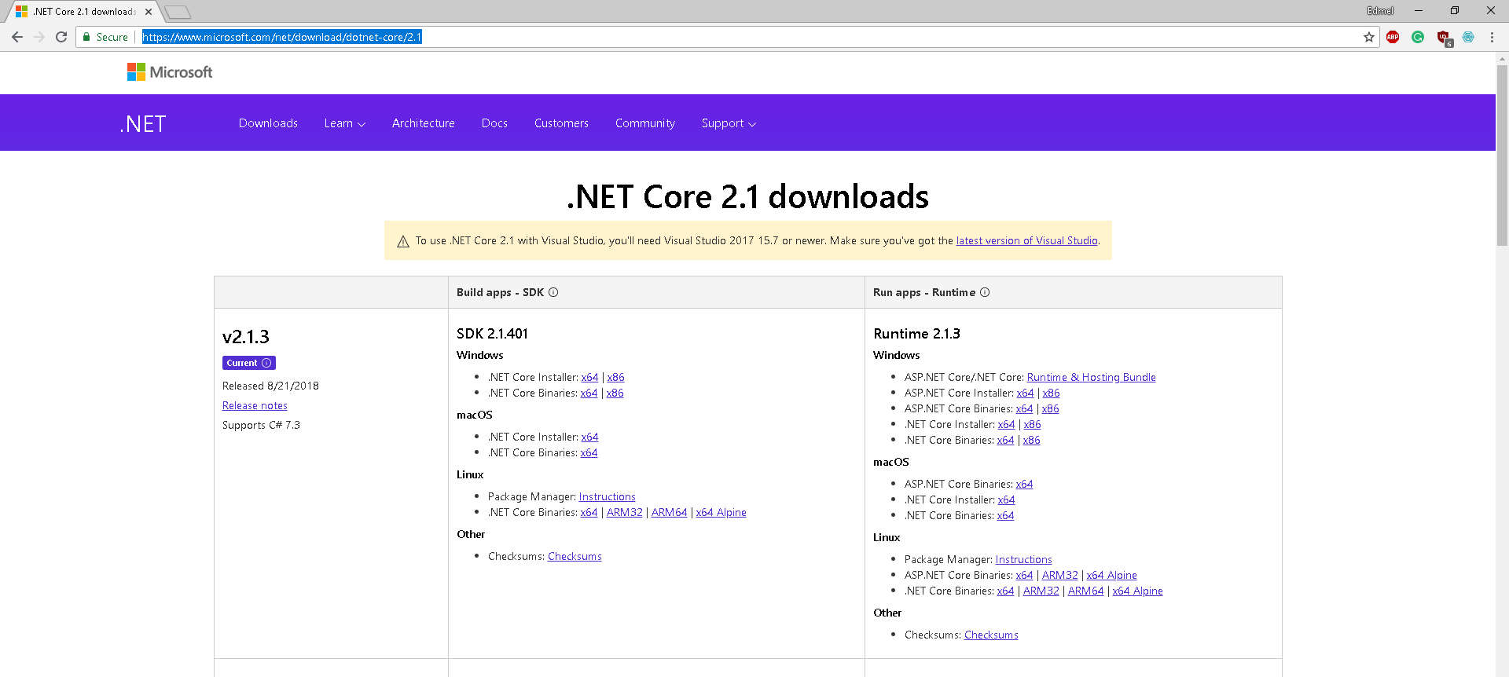

Download the latest SDK as of September 2018 which is 2.1.401

###### **GIT**

Make sure that you also have git install. To download the latest see <https://git-scm.com/downloads>.

###### **IDE**

Highly recommend getting Visual Studio 2017 or Visual Studio Code as your editor. It has powerful extension to help you code faster and be more productive. These extensions are the following you should install to your IDE:

[Productivity Power Tools 2017](https://marketplace.visualstudio.com/items?itemName=VisualStudioProductTeam.ProductivityPowerPack2017) – VS 2017

[Web Essentials 2017](https://marketplace.visualstudio.com/items?itemName=MadsKristensen.WebExtensionPack2017) – VS Code

[Beautify](https://marketplace.visualstudio.com/items?itemName=HookyQR.beautify) – VS Code

[Bootstrap 4 Snippet](https://marketplace.visualstudio.com/items?itemName=thekalinga.bootstrap4-vscode) – VS Code

# **GITHUB/ GIT**

**Master –** this branch is the production branch. Do not make direct changes here unless reviewed or accepted by the team.  
**Branch –** all branches are made for separations of task related .

When working on the assigned task, consider the following:

* The first thing you do is to have a clone of the repository [https://github.com/ejricahuerta/HopeLine.git](https://marketplace.visualstudio.com/items?itemName=thekalinga.bootstrap4-vscode)
* Open IDE and switch from **master** to your assigned **branch –** in our initial branches

master -> webui

master -> authentication-core



this example shows how to switch branches from **authentication-core** to **master**

* Before changing any codes, best practice to perform **git** **pull** or **sync**
* When commit changes, **stage** the file you want to commit and perform **git commit**

**PS: I highly recommend performing gits with cli / bash.**

**VS 2017** - <https://docs.microsoft.com/en-us/vsts/repos/git/gitquickstart?view=vsts&tabs=visual-studio>

**VS Code -** <https://code.visualstudio.com/docs/editor/versioncontrol>

**BASH**

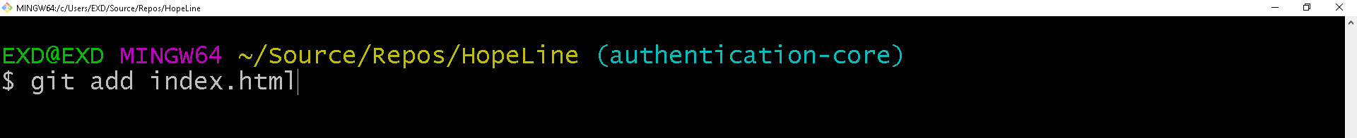adding the file with changes

committing the changes for the branch

  
after performing all commits, perform **git push.**

**MAKE SURE to pull again before start coding.**

* When the branch is ready for review, go ahead and create a [pull request](https://help.github.com/articles/about-pull-requests/).

# **INLINE DOCUMENTATION**

It is important to include documentation for the code you wrote.

**Summary –** ensure to have a summary of the class or function on what is it all about and how to use it.

/// <summary>

/// Generic Repository for all derived BaseEntity classes

/// </summary>

/// <typeparam name="T"></typeparam>

public class Repository<T>: IRepository<T> where T: BaseEntity

**TODO –** include to-dos for if unfinished or needs to be reviewed

public void Delete(T obj)

{

    //TODO: add delete logic with error handling - Eduardo

    throw new System.NotImplementedException();

}

TODO: some_coments – person_needs_to_check_or_update

For **html** **pages**, click [here](https://html.com/tags/comment-tag/).